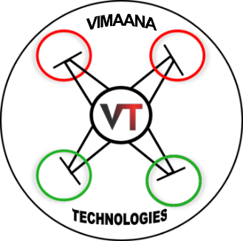 |  | Vimaana Aerospace Technologies
 |  | 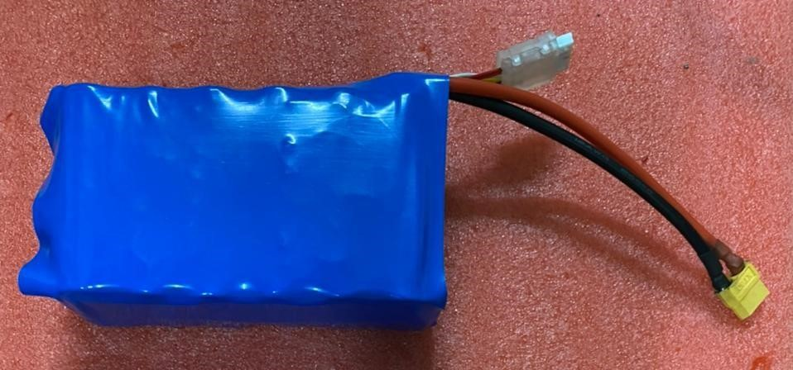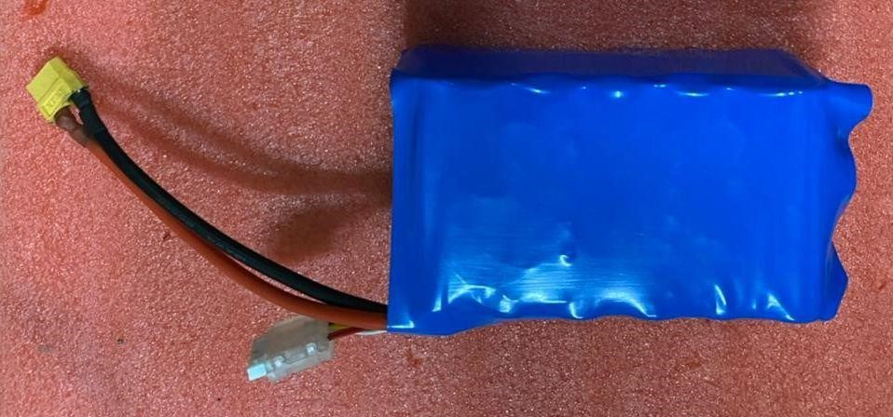
 |  | Customized Li-ion Batteries
S no. | Battery Capacity ( mAH ) | No of Cells | Voltage ( V) | Weight ( g ) | Watt/ hr
1 | 4200 | 2S | 7.4 | 140 | 31.08
2 | 8400 |  | 7.4 | 280 | 62.16
3 | 12600 |  | 7.4 | 420 | 93.24
4 | 16800 |  | 7.4 | 560 | 124.32
5 | 21000 |  | 7.4 | 700 | 155.4
1 | 4200 | 3S | 11.1 | 210 | 46.62
2 | 8400 |  | 11.1 | 420 | 93.24
3 | 12600 |  | 11.1 | 630 | 139.86
4 | 16800 |  | 11.1 | 840 | 186.48
5 | 21000 |  | 11.1 | 1050 | 233.1
1 | 4200 | 4S | 14.8 | 280 | 62.16
2 | 8400 |  | 14.8 | 560 | 124.32
3 | 12600 |  | 14.8 | 840 | 186.48
4 | 16800 |  | 14.8 | 1120 | 248.64
5 | 21000 |  | 14.8 | 1400 | 310.8
1 | 4200 | 6S | 22.2 | 420 | 93.24
2 | 8400 |  | 22.2 | 840 | 186.48
3 | 12600 |  | 22.2 | 1260 | 279.72
4 | 16800 |  | 22.2 | 1680 | 372.96
5 | 21000 |  | 22.2 | 2100 | 466.2
6 | 25000 |  | 22.2 | 2520 | 559.44
NOTE: Batteries can be customized for different connector requirements. These batteries can be used for Drones, RC Aircrafts and RC Cars.

